
PAF-Karachi Institute of Economics & Technology
(The Center of Excellence)
College of Computing and Information Sciences
Software Engineering Course Project Proposal Form

Sno. | Stud. ID | Names | Course Name/CID
1 | 10525 | Rayyan Mirza | Software Engineering
2 | 11260 | Salman | Software Engineering
3 | 11100 | Maaz | Software Engineering
4 | 10643 | Muhammad Shaghil | Software Engineering
5 | 10567 | Muhammad Faisal | 109120

Project Title:

- Motivation:
Restaurants require acquisition, management, and timely retrieval of information in various forms. It should control information areas particularly related to Customer details, Products availability, s Admin’ Details, Customer invoices, etc.

- Functional Features

The existing system is manual – largely paper based and lacks standards. All the information need to be recorded in paper which is very a very tedious and time taking task that cannot be implemented in big Restaurants. In addition to large paper work, it requires manpower in similar quantity, so the existing system is very uneconomical.

Fusion Spice (Restaurant And Customer Order) Management System is a web- based application developed using ASP.NET(Core), C#, Mvc and SQL server database. This project is fully automated and aims at providing effective management services in Restaurants by controlling information such as Customer details, staff Records, Kitchen Managment schedules, Products availability, and Customer invoices . It has a very special feature of locking the users or staff which is not commonly available on many platforms.

- List down 5 unique but relevant Modules/Features for 5 members

Login/Logout feature Both For Customer And Admin.
Social Login (For All)
Stripe Payment (For Customer)
Order Management (For Chef’s)
Order Searching And Confirming Pickup (For Front Desk Worker Who Gives Order)
Food Categories And Sub Categories (Using Foreign Key And Constraints Concepts )
Changing Coupons(By Admin Only)
Shopping Cart + Order History(By Customers Only)
Order Confirmation Email (For Customer)
Date Time Validation (By Admin Only)

There Are Total Four users So Each Member Will Work For Each User As Module
Module 1: Admin(Divided Between Two Members)
Module 2: Admin(Divided Between Two Members)
Module 3: Customer
Module 4: Chef
Module 5:Front Desk

- Expected Detail of all Modules to be covered by each Member
Faisal: Admin Login +Admin Module Half

Creating Food Categories And Sub Categories
Updating Food Categories And Sub Categories
Reviewing Food Categories And Sub Categories
Deleting Food Categories And Sub Categories
Searching Food Categories And Sub Categories

Creating Staff Members
Updating Staff Members
Reviewing Staff Members
Deleting Staff Members
Searching Staff Members

Locking Staff Members

Shaghil: Admin Login +Admin Module Half

Creating Coupon
Updating Coupon
Reviewing Coupon
Deleting Coupon
Searching Coupon

Creating MenuItem
Updating MenuItem
Reviewing MenuItem
Deleting MenuItem
Searching MenuItem

Rayyan: Customer Login + Customer Module

Creating Order
Reviewing Order Confirmation Email
Searching Order History
Deleting Items From Shopping Cart
Paying Through Stripe Payment
Social Login

Maaz : Chef Login + Chef Module

Confirming Cusomter Order
Updating Customer Order
Reviewing Customer Order Requirments
Deleting Customer Order
Searching Customer Orders

Salman : Front Desk Login + :Front Desk Module

Confirming Customer Order Pickup
Searching Customer Orders

- Project Planning

The functionality of the web app will be shown afterwards, and code explanation will also be given at the time of project evaluation , but the concept is easier to understand. This Management system and order system (Combo Of Both) is very simple and can use in very large scaled restaurants to add upgrade and management the products restaurants offer and to overcome order making problems . Projects Work Will be Equally Done by Each Member Of the Group . It will be done in modules accordingly by each member of the group every member will work on there assigned modules.Total time required to complete this project is one month every module will be design and implemented each week so that our project will be completed in four weeks as our project consists of 4 modules.

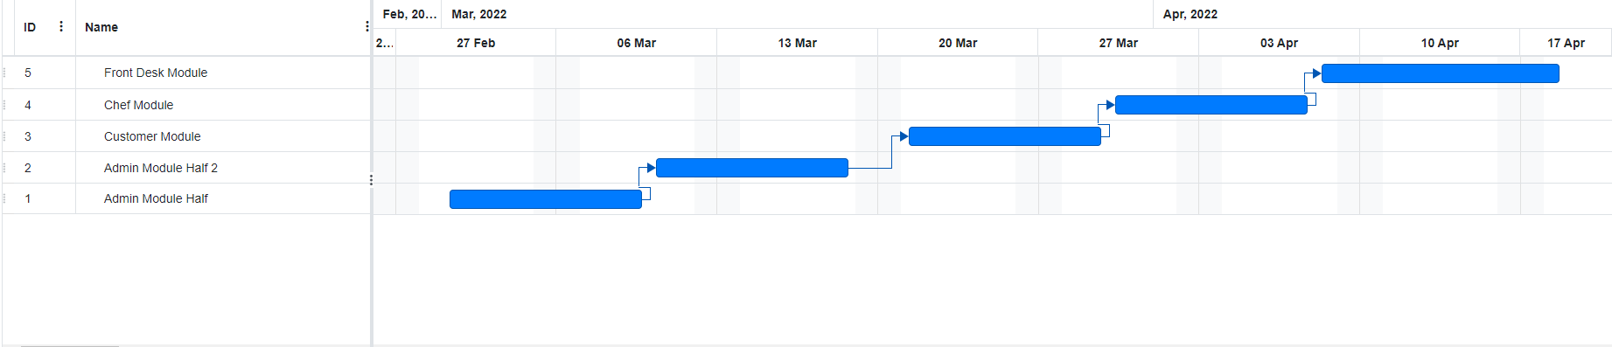

- Diagrammatic Representation of the Overall System

A brief over view the project is shown in the form of a diagram given below.

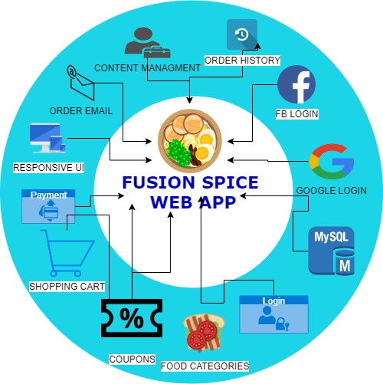

Student’s Signature: M.FAISAL MALIK Student’s Signature: M. SHAGHIL ARSHAD Student’s Signature: Salman
Student’s Signature: Maaz
Student’s Signature: Rayyan Mirza
Date: 3-1-2022

